The Impact of Covid-19 on Aviation. The Economic, Social, Operational, and Litigation Fallout.

American Bar Association International Aviation Litigation Institute
Chicago, Illinois, June 9, 2022

A Panel Discussion

Dan Blaufus, General Counsel, Port of Portland
Scott Brooksby, Partner, Olson Brooksby PC
Nelson Camacho, Esq., Vice President, Aviation, QBE North America
Joshua Gang, Corporate Counsel, Piper Aircraft, Inc.
Roberta Miranda, Esq., Senior Vice President, Senior Aviation Claims Advocate, Marsh Specialty, Aviation
Ann Taylor, Partner, Locke Lord LLP, Chicago

Introduction

The COVID-19 pandemic (hereinafter “COVID”) has had a profound influence on American life. The focus of this paper and the panel discussion is the economic, structural, social, and litigation impact of COVID on the aviation industry. However, a brief contextual discussion may provide helpful context.

According to the United Nations, COVID-related case counts and deaths globally as of 5/7/22 are as follows:

Confirmed Cases Deaths

516,904,681 6,250,163
Epidemics, and, as the world became larger, pandemics, have ravaged the globe for thousands of years. In 430 BC, a plague struck the city of Athens, which was then under siege by Sparta during the Peloponnesian War (431-404 BC). In the next 3 years, nearly the entire population was infected and as many as 100,000 people, or 25% of what was then the largest city on earth, died. During the plague of Justinian, which began in about 542 A.D., the Black Death pandemic killed up to 10,000 people a day, just in the City of Constantinople. Modern estimates suggest that one hundred million deaths (half of Europe) died by the time the pandemic subsided.

There is no question that COVID has been tragic and has directly or indirectly impacted billions of people. COVID’s catastrophic health and economic impacts continue and will persist for a considerable time. However, let us consider the plight of Mr. Shakespeare.

“Sick now! Droop now! This sickness doth infect the very life-blood of our enterprise”
William Shakespeare, Henry IV Part 1, Act 4, Scene 1

“Advise him to a caution, to hold what distance His wisdom can provide.”
William Shakespeare, Macbeth, Act 3, Scene 6

Pursue him to his house, and pluck him thence: Lest his infection, being of catching nature, Spread further.” William Shakespeare, Coriolanus Act 3, Scene 1

“You may be abhorr’d and one infect one another against wind a mile”
William Shakespeare, Coriolanus, Act 1, Scene 4

William Shakespeare lived his entire life in the shadow of the pandemic known simply as the plague or the Black Death. He endured five outbreaks of plague between 1582 and 1609 which killed half of Europe and much of Asia where the Plague originated. He also lost a son to the disease. His plays are filled with references to disease, infection, corruption, and contagion. Although he uses the word “plague” 107 times in his plays, he does not address the topic or its fall-out head-on, in an express description of the consequence. Rather, he alludes to, hints at, and opaquely describes a psychological and emotional world filled with the grief of sickness. His plays are full of frustration, listlessness, anger, and impotence.

During the five outbreaks of plague that marked Shakespeare’s life, the theatres were closed for a collective period of years. When the groundlings disappeared, he had no work and no money and was forced to seek the more elegiac work sought by patrons.

During the plague outbreaks of Shakespeare’s lifetime, social distancing and isolation were seen as two of the most effective remedies for limiting the spread of the plague. However, other remedies included the mass slaughter of cats and dogs, burning ordinary garden herbs, and burning shoes. Shakespeare endured prolonged periods of isolation. He wrote what are his two best plays, King Lear, and Hamlet while in isolation.

Name | Cases-cumulative total | Cases-newly reported in last 7 days | Deaths-cumulative total | Deaths-newly reported in last 7 days | Total Vaccine doses administered per one hundred population | Persons fully vaccinated with last dose of primary series per one hundred population | Persons Boosted per one hundred population
Global | 513,955,910 | 3,640,352 | 6,249,700 | 13,700 | 148.34 | 59.46 | 21.48
United States | 80,854,843 | 432,264 | 989,435 | 3,900 | 171.31 | 65.56 | 29.86
India | 43,094,938 | 22,762 | 524,002 | 249 | 137.29 | 62.57 | 2.08
Brazil | 30,502,501 | 103,497 | 663,759 | 648 | 193.94 | 74.74 | 36.71
France | 28,012,023 | 291,524 | 143,249 | 778 | 231.2 | 80.23 | 70.86
Germany | 25,215,210 | 460,700 | 136.339 | 76 | 207.7 | 76.31 | 59.13
United Kingdom | 22,102,987 | 70,172 | 175,984 | 684 | 209.2 | 73.02 | Unavailable
Russian Federation | 18,216,719 | 41,728 | 376,696 | 969 | 113.7 | 50.22 | Unavailable
Republic of Korea | 17,464,782 | 270,190 | 23,206 | 482 | 238.38 | 86.72 | 64.52
Italy | 16,682,626 | 332,838 | 164,179 | 935 | 227.1 | 79.53 | 65.65
Turkey | 15,038,495 | 10,098 | 98,119 | 68 | 174.8 | 63.77 | Unavailable

According to the World Health Organization, as of 5/7/22 the ten countries with the highest overall COVID-19 case counts and deaths are as follows:

COVID Continues to have, a Profound Impact on Global Aviation: An Overview

Passenger traffic in April 2020 was 96% lower than April 2019 and stayed 60% below 2019 levels in 2020. Effects cascaded across airports, repair shops, and the supply chain. In response to reduced demand, particularly at the outset of COVID in 2019 airlines parked or retired many aircraft, which reduced the demand for maintenance.

COVID had, and continues to have, a profound impact on the U.S. aviation industry. Stakeholders noted the importance of over $100 billion in federal assistance for the aviation sector, including payrolls, rents and more FAA actions included temporary relief from some regulatory requirements.

COVID severely affected the aviation and aerospace sectors that depend on commercial passenger travel. The demand for passenger travel, combined with a broad diaspora of local, state, federal and international strategies for managing COVID and the associated rules and regulations cascaded across U.S. passenger airlines, airports, aviation manufacturers, and repair station operators. Air demand remained low in 2020.
Stakeholders also noted the importance of the over $100 billion in payroll support payments, loans, and other financial assistance provided through COVID-19 relief legislation.
The Federal Aviation Administration (FAA) reported taking quick action to help the aviation industry adjust operations in response to the pandemic. These actions included providing temporary relief from some regulatory requirements—such as airline crewmember medical certifications—and issuing guidance to airlines and airports on mitigating COVID-19 risks. FAA has phased out many of these relief measures.
Although airlines experienced a rebound in demand for U.S. leisure travel in 2021, operational challenges and concerns about the COVID-19 Delta variant have slowed recovery. Forecasts suggest that industry recovery will be uneven as business and international air travel—the most profitable segments—are likely to lag.
Stakeholders identified areas of concern for policymakers to consider, such as strengthening aviation workforce pipelines, as they determine how or whether to continue to assist the industry in evolving market conditions. Further, developing a national aviation-preparedness plan for communicable disease, as GAO recommended, would provide greater coordination among federal and industry stakeholders, and help better prepare the U.S. for future pandemics.

U.S. Airline Passenger Traffic, Percentage Change 2019 versus 2020
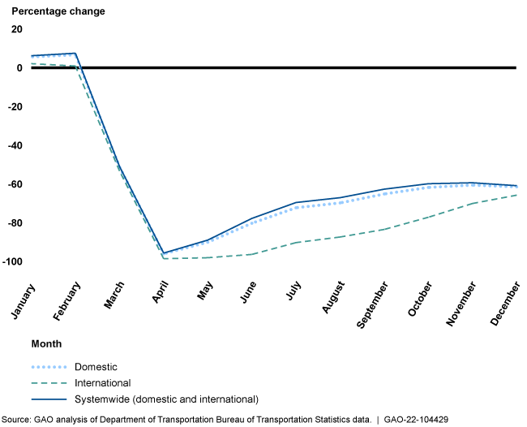

The Close Interdependence and Linkage of the many Constituents that make up the Airline Aviation Industry Include far more Stakeholders than just Passenger Carriers

The air transport sector (passenger and freight) represents only a small share of OECD countries’ value-added (around 0.3 % on average, see Figure 1). Yet, strong inter-industry linkages with both upstream and downstream sectors make it an important part of the economy. On the upstream side, air transportation, aircraft manufacturing, rental and leasing services, and refined petroleum are all heavily interconnected. Of particular importance is the inherent interconnection between air transport and airports. On the downstream side, air cargo is essential for smooth operation of global supply chains. The availability of non-stop intercontinental flights is an important determinant of the location of large firms’ headquarters. Tourism route-availability also contributes to the airport economic engine. COVID’s constructive halt of passenger travel sent shockwaves up and down the linkage from passenger carriers.

Figure 1. Size of the aviation industry, selected OECD economies
Share in total value added, 2017
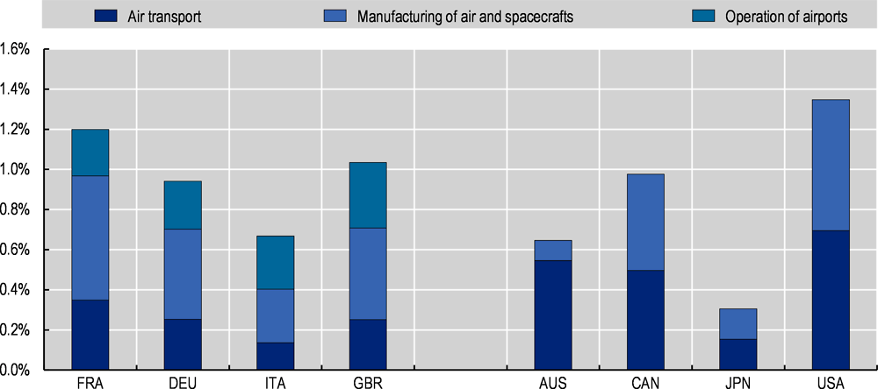
Note: Industries based on ISIC Rev.4 classification (Air transport: Division 51; Manufacturing of air and spacecrafts: Group 303; Operation of airports: Class 5223). Value-added for the operation of airports not available in Australia, Canada, Japan, and the United States. Data from 2016 for Canada and 2018 for the United States.
Source: Calculations based on the OECD STAN Database, http://oe.cd/stan.

Covid’s Impact on Airports

COVID has had an immediate, dramatic impact on airport traffic and revenue. The economic crisis that will follow the pandemic will continue to drive lower demand for air travel, at least into the immediate aftermath, but could extend years depending on future developments.

There are over 4,000 airports around the globe with scheduled traffic. These airports generated revenue of $172.2 billion in 2017, up 6.2 percent year-on-year. Driven by passenger growth, in 2019 total trips exceeded nine billion dollars in revenue. Revenue streams at airports are complicated and involve aeronautical and non-aeronautical income streams. Non-aeronautical streams, including retail concessions, car rental, advertising and food and beverage account for approximately 40 percent of airports’ revenue.

Airport cost structures have high sensitivity to extraordinary events such as COVID. Airports have high fixed costs associated with the provision and maintenance of infrastructure, safety, and security, regardless of traffic levels. Operating expenses comprise about 65% of total costs and include staff costs (30-40 percent), contracted services (20-25 percent), utilities (about 7 percent) and rent or concession fees (about 7 percent). Capital costs (on average, 35 percent) comprise depreciation (about 65%) and interest payments (about 34%); Air travel and tourism, directly and indirectly, contribute about 10 percent of global GDP and 330 million jobs

The onset of COVID which began in Asia-Pacific and spread around the globe and measures in response-such as government recommendations to avoid travel and airport closures led to a 53.1 percent drop in global air traffic by March of 2020, equivalent to a 620 million passenger reduction. By April 2020, passenger traffic was down 90%. This led to a 57 percent drop in airport revenues in 2020. Airline bankruptcies and financial instability, structural change, and revenue losses and credit downgrades all pose long-ranging COVID-related risk

Quarterly Total Airport Revenues in 2020 by region:
Forecasted (Pre-Covid-19) vs. Estimated Under (COVID-19) (Million USD)

 | Forecasted (pre-COVID-19) | Estimated under (COVID-19) | % Change
Africa | 4,300 | 2,100 | -51.2%
Asia-Pacific | 49,900 | 20,500 | -58.9%
Latin America-Caribbean | 10,500 | 5,200 | -50.5%
Middle East | 13,200 | 6,200 | -53.0%
North America | 34,700 | 18,300 | -43.3%
World | 171,900 | 74,500 | -56.7%
Source: Airports Council International (ACI)

COVID’s Impact on Airlines

There can be little debate that COVID hit airlines harder than any other aviation subsector. According to one study the airline sector was not doing particularly well before the pandemic, and between 2012 and 2019, despite strong economic growth and low fuel prices, airlines were losing $17 billion in economic profit per year, on average. Of the 122 carriers studied, 77 percent were value destroyers, but the average losses of airlines before the pandemic were only around one-tenth of their $168 billion in losses for 2020. Revenues plummeted by 55 percent, setting the airline passenger subsection of aviation back 16 years.

All regions contributed to the overall losses in 2020, including North America. Five of the world’s ten top-performing airlines during the during the 2012-2019 period were based in the United States, where years of consolidation and restructuring had left the North American market with a few leading players. However, the major airlines were not immune from the COVID pandemic and lost $63 billion in 2020 alone. While full data is not yet available for 2021, the McKinsey study estimates net losses of around 11 percent.

Reasons for the persistent weakness of airlines are well documented and include high capital intensity, fluid supply and low entry barriers. The large field of carriers means that suppliers such as OEMs and airports have stronger negotiating power. On the customer side, passengers hold significant power and are price driven. The airline seat remains commoditized despite airline efforts at differentiation.

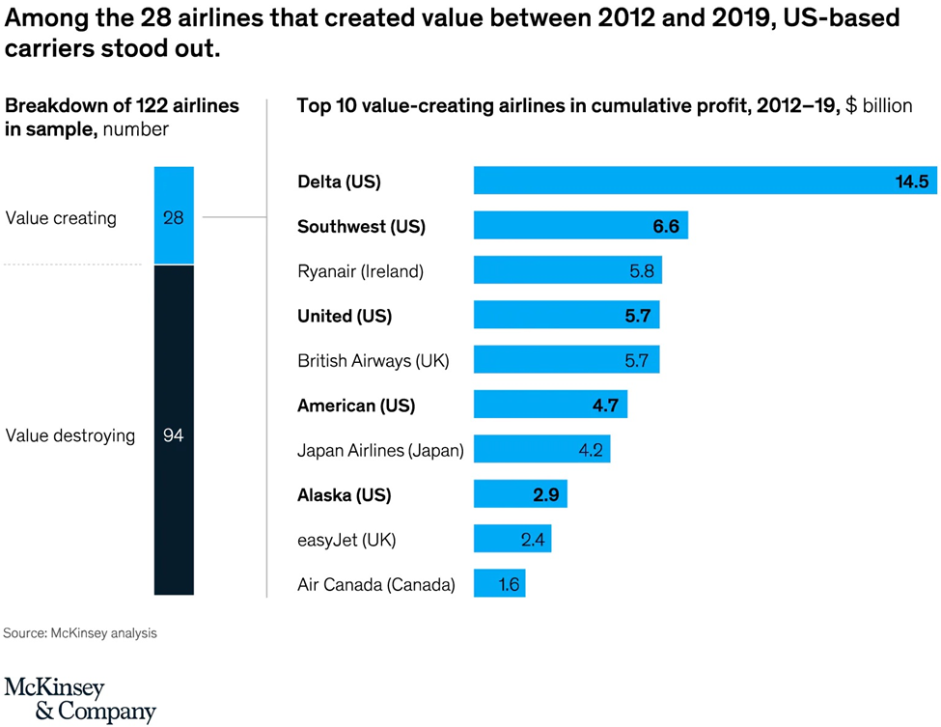

COVID’S Impact on Aviation Manufacturing

General Aviation Manufacturers Association (GAMA) leaders have forecasted a healthy rebound in aircraft demand once the impact of the COVID pandemic has passed. This is in part due to expected innovations in electric propulsion and supersonic technologies. Speaking at the GAMA 2021 State of the Industry address, GAMA Chair Nicolas Chabbert noted that the pandemic caused a 9.7% decline in airplane shipments in 2020 and a 14.8% drop in total airplane billings.

NBAA and GAMA data suggest that while GA manufacturing experienced a Q4 2020 rebound, the pandemic still had heavy negative impact on 2020 shipments and billings. The least affected segment, piston airplanes, saw deliveries drop just 0.9% year-over-year to 1,312 units, but turboprop shipments declined 15.6% to 443 units and business jet deliveries fell 20.4% to 644 aircraft. The value of airplane deliveries for 2020 dropped 14.8 percent compared to 2019 to $20 billion. Preliminary civil-commercial helicopter deliveries also fell 17.7% to 674 units and billings dropped 16.2% to 2.7 billion compared to 2019.

With respect to the commercial aircraft manufacturing sector, COVID has had disastrous effects. In part, the commercial order nose-dive has been caused by an ever-evolving amalgam of rules, health regulations and travel restrictions and advisories from every country in the world, all of which contributed to plummeting demand for long-haul international travel. The U.S. State Department’s 4-level travel advisory has been fluid through the pandemic and continues to change daily. The drop in international passenger demand globally has been the principal downward driver in new aircraft orders, deliveries, and price negotiations.

The hardest hit to commercial manufacturing has been to wide-bodied jets. The primary challenges facing airlines have been passed to the upstream global aviation industry by deferral of new plane deliveries, along with a slump in new orders, and cancellation. This is seen by some as a direct result of the decline in demand for long-haul flights. Some have predicted that a drop in new plane deliveries by -57% and -26% in 2021 and 2022.

Airbus and Boeing are expected to deliver a total of 539 and 910 new planes in 2020 and 2021, respectively, compared with 1,610 in 2018 and 1,243 in 2019. The lower number in 2019 is the consequence of the flying ban imposed on Boeing 737 Max jets since March 2019, and while 2021 and beyond should see a slight recovery, the number of new plane deliveries is still likely to remain far below its pre-pandemic level of 1,600 units a year if the global economy remains off track.

COVID’S Impact on the Aviation Insurance Market and the Key Role of Insurers and Brokers

By the end of March 2020, approximately 8,500 airliners were grounded. One of the initial insurance risks was mass accumulation. The mass accumulation exposes aviation insurers to significant one-off loss events such as tornadoes, hail, terrorist attacks and other catastrophes that could create billions of dollars in losses at once. The aviation insurance market has suffered significant losses in recent years, most notably related to the grounding of the Boeing 737 Max. Through 2019 and 2020, the global aviation insurance marketplace hardened, but COVID will slow down insurer efforts to return balance sheets to a healthy place.

When large fleets of aircraft are grounded, the insured airlines typically request one of two things. They request either ground breaks, which typically means a request to pay a lower premium, or they ask for a lay-up credit, which impacts the aviation insurance marketplace by lowering the amount of available premium. If the insurers agree to premium credits on hull and liability policies, the credits are typically between 30-50% of the annual premium on a prorated basis. The average cost of a claim has spiked between 32% and 133% depending on the loss.

There are also numerous downstream effects from COVID on thousands of other aviation businesses. These downstream businesses include parts, avionics, component, and repair providers. The impact on catering and related support business has been financially punishing. Recent advances in technology, such as carbon fiber, and multi-stage compressors which are manufactured as a single piece, including compressor blades, have resulted in greater damage. The higher damage repair costs and initial lack of demand for parts, have impacted the insurance market.

For example, a wing-tip repair on a metal airliner would not typically exceed $50,000. In contrast, a carbon fiber wing tip repair can easily cost $1.5 million. With the COVID-related demand from downstream suppliers at a virtual ground stop, particularly in the first year of the pandemic, there are lower revenues across the board which provide a lower rating basis for the insurers servicing downstream businesses.

The aviation insurance broker community was quick to respond to the Covid-19 crisis. Early on aviation brokers were investigating options with clients and underwriters designed to mitigate the imminent difficulties. Across the various aviation sectors brokers supported their clients during one of the most uncertain times in aviation history by providing a broad range of risk and insurance solutions. The pandemic was undoubtedly a game-changing event in aviation insurance. Insureds worldwide faced challenging renewals with uncertain outcomes. The potential for changes in premium and coverage grew as the Pandemic wore on, against the backdrop of an already firming insurance market pre-Pandemic.

Coronavirus brought worldwide air travel to an unprecedented slowdown. Airline insurance premiums are adjustable based on the actual exposures (e.g., number of passenger miles flown), and the substantial decrease of flights had the potential to result in a significant reduction to the expected premium, and possibly cause some insurers to stop writing aviation. These issues trickled down to all sectors of the aviation industry, not just airlines.

Thankfully, Covid-19 generated minimal insurance claims activity in the aviation industry. While the aviation market faced very few transmission claims (i.e., allegations that passengers contracted COVID-19 while on board an aircraft), the more common lawsuit alleged claims arising from denied boarding of passengers that appeared sick or otherwise related to mask mandates. Nonetheless, the trickle of these specious and highly non-lucrative claims did not come close to being the market-changing event that some feared. Notwithstanding, brokers were faced with challenging new coverage issues and various pandemic-related exclusions that several markets sought to impose in response to Covid-19. This created a good deal of uncertainty surrounding whether policies would respond to existing and potential future claims

Environmental Issues

COVID has had an environmental and/or environmental/economic hybrid impact on aviation too. For example, unnecessary “ghost flights” and the need to justify nonuse of slots for low demand has been problematic, particularly in the EU. There has been a contentious debate over slots. Airlines are not flying empty planes, but EU slot rules with few exceptions are forcing airlines to fly with extremely low loads.

Airlines would prefer to be environmentally responsible and cancel these unnecessary flights while rescheduling on to fewer flights to keep pax flying. The European Union Commission has confirmed it will be adopting a Delegated Act for Summer 2022 which reduces the slot use threshold to 64% (64/36) for the season and provides extension of the existing COVID-related JNUS exceptions. Although full treatment of worldwide slot guides is beyond the scope of this paper, for additional information on impact of COVID on slot guides, see The Worldwide Airport Slot Guides (WASG).
Aviation Litigation Related to COVID

Flight Crew Mask Mandate Litigation

Judge Kimberly Mizelle’s Decision Striking Down the Biden Administration’s Mask Mandate

Most COVID-related aviation litigation involves mask mandates or requests for refunds.

On April 18, 2022, U.S. District Judge for the Judge Kimberly Mizelle, (U.S. District Court for the Middle district of Florida) struck down the mask mandate. In Health Freedom Defense Fund, Inc., et al., v Joseph R. Biden, Jr. Case No 8:21-cv-01693-KKM-AEP, 2022 WL 1134138 4/18/22 the court issued its 59-page opinion. The judge’s decision freed airlines, airports, and mass transit systems to make their own decisions about mask requirements. The major airlines immediately switched to a mask optional policy. The transportation Security Administration, just hours after the opinion was released, announced it would no longer be enforcing the mask requirement. The CDC had recently extended the transportation mask mandate, which was set to expire on May 3, to allow more time to study the COVID-19 BA.2 Omicron subvariant that is not responsible for most U.S. cases.

Judge Mizelle, an appointee of former President Donald Trump, said the U.S. Centers for Disease Control and Prevention exceeded the bounds of their authority, failed to justify their decision, and did not follow proper rulemaking procedures leaving the ask mandate fatally flawed.

The U.S. Department of justice has been silent about plans to challenge the ruling. Although Judge Mizelle’s opinion is likely to face challenges, it follows countless lawsuits challenging the mask mandates.

In Trocano v Centers for Disease Control & Prevention, et al., Case No 1:22-cv-00727-MSK, United States District Court for the District of Colorado, (filed 3/24/22) nine commercial flight attendants filed a 61-page complaint to vacate and permanently enjoin enforcement of the Federal Transportation Mask Mandate (“FTMM). The flight attendants, who were employed by Allegiant, American, Delta, Frontier, southwest and United argue that forcing them to obstruct their normal breathing, harms their health and being required to enforce the mandate endangers aviation safety as tens of thousands of passengers refuse to comply.

In the lawsuit, plaintiffs also argue that intense arguments and physical altercations occur between passengers and crew members, but also among crew members themselves with varying opinions, which pose more safety threats. The nine flight attendants express concern that CDC and HHS ignore that the mask mandate recklessly endangers aviation safety and security by causing numerous disruptions in the cabin. As of 5/10/22, no further action has been taken by any party.

The CDC and HHS airline mask mandate went into effect in February 2021, a year after the declaration of the COVID-19 pandemic. Just a few days before the Trocano lawsuit was filed, a group of ten pilots from American, JetBlue and Southwest Airlines sued the Centers for Disease Control and Prevention and the Department of Health and Human Services over the federal mask mandate. The mask mandate was originally set to expire on April 18, 2022. It was then extended until May 3 to allow more time to study the COVID-19 BA.2 Omicron subvariant that is not responsible for most U.S. cases. This is believed to be the first suit by aviation transportation workers to challenge the mask mandate.

In Carlin, et al., v Centers for Disease Control & Prevention, et al., Case No. 1:22-cv-00800, United States District Court for the District of Columbia, the same lawyer representing plaintiffs in the Trocano lawsuit filed a similar 61-page complaint. The pilot’s lawsuit cites numerous health issues brought about by mandated face masks on airplanes and in the air system. They also claim that face masks are ineffective in preventing transmission of the virus, and the recent surge in air rage incidents on airplanes has been fueled by the face mask mandate. As of 5/10/22, there have been no developments since the case was filed on March 15, 2022.

Wrongful Death Litigation

In Estate of Madden, et al., v Southwest Airlines Co., Case No. 1:21-00672 SAG (filed 3/17/21) 2021 WL 2480119, Slip Copy, June 23, 2021, filed in the United States District Court for the District of Maryland, a Southwest Airlines flight attendant filed a wrongful death lawsuit against the airline, alleging that lax COVID protocols during mandatory training, and slack contract tracing after an attendee tested positive, led to her husband’s death from the virus. Carol Madden, the 69-year-old Baltimore flight attendant is seeking more than $3 million in damages for negligence.

She and her husband, Bill, a veteran and retired railroad signal engineer who drove her home from the one-day training session at BWI got sick days after the training and tested positive for COVID. Bill’s oxygen levels plunged, and he died a few weeks later in a Pennsylvania hospital. COVID pneumonia was listed as the first cause of death. Madden alleged that Southwest was cleaning seats, air vents, seatbelts, and every touch point, but the airline allegedly did not do that in her training the previous year. Southwest Airlines filed a motion to dismiss on April 23, 2021, and the case was closed on 6/23/2021 without a ruling on Southwest’s motion.

Passenger Refund Lawsuits

In 2020, airlines faced over thirty class actions seeking refunds for COVID-19 related flight cancellations. A representative sample is discussed below.

Southwest Airlines COVID-19 Lawsuits

Southwest, the largest domestic carrier in the United States, is being sued for breach of contract due to its failure to offer refunds for cancelled flights. In Bombin v Southwest Airlines Co.,529 F.Supp.3d 411 3/29/21, Case No. 5:20-cv-01883, United States District Court for the Eastern District of Pennsylvania, plaintiff alleges that the airline cancelled flights that would not be profitable due to COVID-19. According to the complaint, Southwest cancelled an additional 1,500 flights daily due to declining demand.

The complaint alleges that Southwest did not offer refunds, and instead offered a rebooking to a different Southwest route or a travel credit. Plaintiff alleged this policy conflicts with Southwest’s Contract of carriage which mandates refunds if another flight cannot be arranged. Plaintiff further claims that Southwest is in violation of the Department of Transportation’s Enforcement notice that requires airlines to offer refunds to customers impacted by COVID-19 -related cancellations.

Plaintiff seeks class certification on the basis that the proposed class members include people throughout the United States that are so numerous and geographically dispersed that joinder would be impractical. Southwest filed a motion to dismiss primarily based on breach of contract. Southwest argued that under the contract of carriage, Southwest alone can decide to offer credits when it cancels a flight. The court rejected this argument and noted the contract of carriage stated plainly that customers will have the option to receive a refund when Southwest makes any change to a flight schedule more than seven days before departure. Southwest’s motion to dismiss was denied. As of 5/6/2022, discovery is proceeding.

United Airlines COVID-19 Lawsuits

United Airlines also faces a class action lawsuit. In Rudolph v United Airlines Holdings, Inc., Case No. 1:20-cv-02142, United States District Court for the Northern District of Illinois, 519 F. Supp.3d 438, 2/12/21, 2020 WL 1676340. Plaintiff Jacob Rudolph booked flights for April 2020 on United. However, in March, plaintiffs’ employer-a police department-cancelled all vacation for officers as the pandemic began to surge.

Plaintiff requested a refund from United which was denied. United explained that a refund would only be issued if the flight was cancelled, and instead offered to book him on a different flight or issue a travel credit. Plaintiff’s flight was cancelled, but United continued to deny any refund. The complaint also cites a letter to United’s CEO from several Senators urging the company to issue refunds, especially given the $25 billion in federal aid recently issued to the airline industry. Plaintiff seeks class certification for a class defined as other in the U.S. who booked flights with United from March 1, 2020, through present day and were denied a refund.

On April 6, 2020, plaintiff filed the class action complaint. United filed motions for summary judgement and motions to stay, which were abated pending arbitration. On 7/17/2020, plaintiffs moved for transfer under 28 U.S.C. §1407 for coordinated pretrial proceedings with the COVID -19 Airfare Refund Litigation. A series of thirty-eight putative class actions pending in sixteen different U.S. District Courts alleging passenger airlines have refused to offer required refunds for flights the airlines cancelled in response to the COVID-19 pandemic. As of 5/9/22, discovery is proceedings and motions to compel have been filed.

Delta Airlines COVID-19 Lawsuits

A similar lawsuit, Daniels v Delta Airlines, Inc., Case No. 1:20-mi-99999-UNA, United States District Court for the Northern District of Georgia, 2020 WL 12948052 alleges breach of contract, unjust enrichment, conversion, fraudulent misrepresentation, as well as violation of consumer protection laws for failing to provide full refunds for plaintiff’s twice cancelled flight to Cairo.

In response to the first cancellation in March 2020, he elected to rebook on a different date. However, when Delta cancelled the second flight, plaintiff’s request for a refund was denied. He was informed he could receive a voucher for travel credit valid for one-year from his original booking date. The complaint alleges that Delta’s actions were in contradiction to its contract of carriage which states that a full refund will be given for any cancelled flight. The proposed class would cover all consumers who purchased airline tickets on flight scheduled between March 1, 2020, and the present day and were denied a refund. Delta has countered that it issued one million refunds in March, and that the plaintiff was issued his refund a day after the class action was filed.

As of 5/10/22, class counsel has been appointed and the case is proceeding.

American Airlines COVID-19 Lawsuits

Just after filing the class action against Delta, the same counsel filed a similar case against American Airlines. Ward v American Airlines, Inc., Case No. 4:20-cv-00371-Y, 498 F.Supp.3d 909, 2020 WL 8415080 United States District Court for the Northern District of Texas.

In Ward, plaintiff had a portion of his return trip from Lima, Peru to Las Vegas booked through American Airlines. However, Ward’s flight was cancelled on March 27, 2020, and the next available return flight was not until May 7, 2020.

American refused to issue a refund, despite stating such in their conditions of carriage. Plaintiff alleges that American focused on keeping passenger money through providing travel credits, not refunds. The complaint alleges breach of contract, unjust enrichment, conversion, fraudulent misrepresentation, and violations of state consumer protection acts. The proposed class is defined as any person in the U.S. who purchased American flights between March 1, 2020, and the present day and were not issued a refund for a cancelled flight.

All the airline putative class actions involve alleged refusal by airlines to issue refunds and reference the Department of Transportations coronavirus-related Enforcement Notice. The April 3, 2020, notice was released by DOT’s Office of Aviation Enforcement and Proceedings to remind the traveling public and U.S. and foreign carriers that passengers should be refunded promptly when their scheduled flights are cancelled or significantly delayed.

American Airlines filed a motion to dismiss and a motion to compel arbitration. At the outset, Judge Reed O’Conner noted the allegation that American cancelled 55,000 flights in April 2020 alone, and as American announced flight cancellations, it took steps to make it difficult, if not impossible for passengers to receive a refund for flight cancellations. In doing so, plaintiffs alleged American violated the terms of its contract of carriage. All three plaintiffs, Ward, Saunders, and Holloway brought claims alleging American improperly refused to issue refunds under various theories of relief. Plaintiffs Holloway and Saunders purchased tickets through Expedia, and plaintiff Holloway purchased a ticket through Hotwire. All plaintiffs alleged a failure to refund ticket purchase prices after American cancelled their flights. The Expedia online purchase agreement contained a mandatory binding arbitration clause which included claims against beneficiaries of the arbitration agreement, such as travel suppliers.

American moved to dismiss based on the mandatory arbitration clause. Plaintiffs Saunders and Holloway voluntarily withdrew their claims for violation of state consumer protection acts, unjust enrichment, conversion, and fraudulent misrepresentation. American moved to dismiss Saunders and Holloway’s breach of contract claims on the basis that their claims were not within the scope of the arbitration clause and American alleged it was not a direct party to the arbitration clause.

The court rejected Holloway and Saunders arguments and found that the arbitration agreement was binding under the express terms of the online sale agreement. However, since American was not a direct party to the online sales agreement, the Court ruled that Under Texas law, American could only invoke the arbitration clause as a third-party beneficiary of the Terms of Use. The court also ruled that the breach of contract claims were within the scope of Expedia’s Terms of Use.

The Court also ruled that with respect to Ward’s breach-of-contract claim, no stay pending arbitration was required and that Ward’s claims with the other plaintiffs had no possible adverse effect on the arbitration proceedings. American moved to dismiss Ward’s claim. In response, Ward dismissed all state-based consumer claims and proceeded based solely on a claim that American breached the terms of its Contract of carriage.

The Court also ruled that Ward correctly stated the elements for a breach of contract case based on the contract of carriage. The court also found that irrespective of ticket types, American conceded that if a passenger decides not to fly because the flight was delayed or cancelled, American will refund the remaining ticket value and any optional fees, even for nonrefundable tickets.

Because Holloway and Saunders could proceed under arbitration, their claims were dismissed with prejudice. Ward’s breach of contract claim was allowed to proceed. As of 5/10/22, Ward’s case is proceeding.

The Dismissal of the COVID-19 Flight Cancellation and Refund Class Action Lawsuit Brought Against Norwegian Air.

In one of the earliest resolutions of COVID-related airline litigation, the United States District Court for the Central District of California issues an order dismissing a putative class action against Norwegian Air without leave to amend. Daversa-Evdyriadis v Norwegian Air Shuttle, No. 5:20-cv-00767-JGB-SP, (9/17/20) (ECF No. 32). The plaintiff brought a single claim or breach of contract. She alleged that although she had received a refund for her cancelled flight, the refund came too late. She argued that the delay violated DOT regulations that require a refund within seven days of the cancellation and that those regulations were incorporated into Norwegian Air’s contract of carriage

The Court rejected this argument and held that “boilerplate contractual language guaranteeing compliance with international or domestic aviation laws does not incorporate extraneous law into the terms of an airfare contract.” The court explained that a contract provision “that identifies an exact regulation or statute and guarantees compliance with it” is sufficient to incorporate that law, but that a contract that broadly vows to abide by all applicable laws is not.

United Nations Department of Economic and Social Affairs, Statistics UN COVID-19 Data Hub file:///C:/Users/sbrooksby/OneDrive%20-%20Olson%20Brooksby%20PC/Documents/UN%20COVID-19%20Data%20Hub.html Last visited 5/8/22
“ A sudden outbreak of infectious disease that spreads rapidly through the population, affecting a large proportion of people” Oxford English Dictionary, https://www.google.com/search?q=Oxford+english+dictionary+definition+of+epidemic&rlz=1C1CHBF_enUS922US922&oq=Oxford+english+dictionary+definition+of+epidemic&aqs=chrome..69i57j0i22i30j0i390.13462j0j15&sourceid=chrome&ie=UTF-8 Last visited 5/8/20.
“An epidemic occurring over a very wide area, crossing international boundaries, and usually affecting a large number of people”, Oxford Reference https://www.oxfordreference.com/view/10.1093/acref/9780199976720.001.0001/acref-9780199976720-e-1373#:~:text=An%20epidemic%20occurring%20over%20a,a%20large%20number%20of%20people. Last visited, 5/9/20.
“The plague of Athens: epidemiology and paleopathology,” Littman, Robert J., Mt. Sinai J Med. Oct. 2009 https://pubmed.ncbi.nlm.nih.gov/19787658/ Last visited, 5/10/22
“Plague was one of history’s deadliest diseases-then we found a cure” Howard, Jenny, National Geographic Society, July 6, 2020, https://m365.us.vadesecure.com/safeproxy/v4?f=WOgceN-hUA-lF2H7Gu4E6OavOR4gkpoT76yAub_HK0My0mPXQSLEB3c9BGmxW9RT&i=H_IkNxwocPmcSuFXDV8s8sgOdFCEcRjAMWiLtvNhShCUlXJ0_c59dRFswjfEjcJI497YQhVzTE0-e4-FyAhWfA&k=XX0E&r=nyuZQx9kXgS7mUxr1JCBMYxgNOLF_ovmS9tGeoZx0R0jAlnKrSMkd7u6Attj3S97&s=b63f4d3e15ec3b44f479e7c76cc27bb2360be2d8b225bfeec9ab5d343e7cd8e1&u=https%3A%2F%2Fwww.nationalgeographic.com%2Fscience%2Farticle%2Fthe-plague Last visited, 5/8/2020.
“Speaking what we feel: Shakespeare’s plague plays”, Austin Tichenor, Folger Shakespeare library, August 27, 2021, https://shakespeareandbeyond.folger.edu/2021/08/27/speaking-what-we-feel-shakespeares-plague-plays/#:~:text=Shakespeare%20was%20born%20during%20a,all%20of%20Shakespeare's%20professional%20life. Last visited 5/9/22
World Health Organization, WHO Coronavirus (COVID-19) Dashboard, “Situation by Region, Country, Territory & Area.” Only the countries with the top ten most deleterious COVID-19 impacts are detailed in this table. https://covid19.who.int/table Last visited 5/8/22.
COVID-19 Pandemic: Observations on the Ongoing Recovery of the Aviation Industry, GAO-22-104429), October 21, 2021. https://www.gao.gov/products/gao-22-104429#:~:text=The%20COVID%2D19%20pandemic%20had,shops%2C%20and%20the%20supply%20chain. Last visited 5/6/2022.
Id.
COVID-19 and the Aviation Industry: impact and policy responses https://www.oecd.org/coronavirus/policy-responses/covid-19-and-the-aviation-industry-impact-and-policy-responses-26d521c1/ Last visited, 5/8/22.
Id., citing IATA data that approximately 50% of an airline company’s costs are variable with fuel accounting for 25% of total costs.
The Impact of COVID-19 on Airports: An Analysis, World Bank Group, International Finance Corporation. https://www.ifc.org/wps/wcm/connect/26d83b55-4f7d-47b1-bcf3-01eb996df35a/IFC-Covid19-Airport-FINAL_web3.pdf?MOD=AJPERES&CVID=n8lgpkG Last visited 5/9/22
Id.
Id.
Id.
“Taking Stock of the pandemic’s impact on global aviation”, Bouwer, Krishnan, Saxon and Tufft, March 31, 2022 McKinsey & Company https://www.mckinsey.com/industries/travel-logistics-and-infrastructure/our-insights/taking-stock-of-the-pandemics-impact-on-global-aviation Last visited 5/10/22
Id.
Id.
Id.
“Aircraft Manufacturers optimistic for Robust Recovery from Pandemic Downturn, National Business Aviation Association, February 24, 2021 https://nbaa.org/aircraft-operations/safety/coronavirus/covid-19-point-of-impact/aircraft-manufacturers-optimistic-for-robust-recovery-from-pandemic-downturn/ Last visited 5/9/22
Id.
Id.
U.S. Department of State-Bureau of Consular Affairs Travel Advisories https://travel.state.gov/content/travel/en/traveladvisories/traveladvisories.html/ Last visited 5/10/22
“The global aerospace industry faces a steep cost of contagion.” Allianz, October 2020. https://www.allianz-trade.com/en_global/news-insights/economic-insights/The-global-aerospace-industry-faces-a-steep-cost-of-contagion.html Last visited 5/10/22.
Id.
ACE, Aerospace Central Europe, “The Coronavirus Pandemic Poses a Unique Risk to the Aviation Industry and Compels Aviation Insurers and Brokers to Adapt Their Strategy”, April 2021, https://aero-space.eu/2021/01/04/the-coronavirus-pandemic-poses-a-unique-risk-to-the-aviation-industry-and-compels-aviation-insurers-and-brokers-to-adapt-their-strategy/ Last visited 5/10/22.
Id.
Id.
Id.
“IATA COVID-19: SLOTS” https://www.iata.org/en/policy/slots/covid-19-slots/ Last visited 5/8/22.
IATA, Worldwide Airport Slot Guides https://www.iata.org/en/policy/slots/slot-guidelines/ Last visited 5/8/22.
United States of America Department of Transportation Office of the Secretary Washington D.C. “Enforcement Notice Regarding Refunds by Carriers Given the Unprecedented Impact of the COVID-19 Public Health Emergency on Air Travel”, Blaine A. Workie, Assistant General Counsel for Aviation Enforcement and Proceedings, April 3, 2020 https://www.transportation.gov/sites/dot.gov/files/2020-04/Enforcement%20Notice%20Final%20April%203%202020_0.pdf Last visited 5/9/20.

